
FAKULTI KOMPUTERAN

MID SEMESTER EXAM
SEMESTER 1 2022/2023

COURSE CODE | : SECD2523
COURSE NAME | : DATABASE
YEAR / PROGRAM | : 2/SECB, SECJ, SECV, SECR
TIME | : 8:00 – 10:30 PM (2 hours 30 minutes)
DATE | : 30 NOVEMBER 2022
PLACE | : BK1 – BK7, MPK 1-2 (N28)

----------------------------------------------------------------------------------------------------------------

INSTRUCTIONS TO CANDIDATES:
- Fill in your particulars in the question booklet and answering booklet:
Name
IC No.
Matrix No.
Year / Program
Course Code/ Section
Lecturer

- Read instructions given for each question carefully.

- Answer ALL questions in the ANSWERING BOOKLET given.

- This paper consists of THREE parts; Part A: 20 MCQ questions
Part B: 4 STRUCTURED questions
Part C: 1 CASE STUDY question

- Submit BOTH answering booklet and question booklet at the end of the exam.

THIS PAPER CONSISTS OF 13 (THIRTEEN) PRINTED PAGES INCLUDING THIS PAGE.
PART A: MULTIPLE CHOICE QUESTION (20 MARKS)

- Choose the terminology which has the correct description.
- Database refers to a collection of large data.
- Database Management System is the software that manages and controls access to the database.
- Database application refers to the collection of application programs that interact with the database along with the DBMS and database itself.
- Database system is a program that interacts with the database at some point in its execution.

- Charlie's Chocolate Factory has finally moved to Database system from their file-based system. Jennie Joy is one of the team members of the Database team who will have to develop and maintain the standards, policies and procedures as well as plan the database. What is Jennie Joy's position in the Database team?
- Data Administrator
- Database Administrator
- Database Designer
- Application Programmer

- The following are the levels in the ANSI-SPARC architecture EXCEPT:
- External level
- Conceptual level
- Internal level
- Physical level

- This key is also known as minimal superkeys.

What is the key that fulfills the description above?
- Primary key
- Candidate key
- Composite key
- Alternate key

- What is an alternative name for a row referred to in a relational database?
- tuple
- degree
- cardinality
- attribute

- What can be achieved during the system definition?
- The list of major users.
- Details of how data is generated.
- Types of DBMS selection.
- Merge the user requirement into a single set.

- Below shows examples of relational schema for a university which consist of LECTURER, STUDENT, COURSE and GRADE written as follows:

LECTURER (StaffNo, ICNum, Position, Department)
STUDENT (StdID, Name, CourseCode)
COURSE (CourseCode, Name, Unit, StaffNo)
GRADE (StdID, CourseCode, Gradepoint)

Based on the above relational schema, identify the relational key for attributes CourseCode from the GRADE relation.

- Superkey
- Composite key
- Alternate key
- Foreign key

- Determine the ADVANTAGE of developing a data dictionary in a database.
- Significantly reduce the cost of hardware charge and maintenance.
- Increase the complexity of the administrator or new DBA to understand the database.
- Provide clear details on the relations, views, constraints, and indexes.
- Easy to be developed to facilitate the understanding of non-technical users of the system.

- Which of the following is TRUE about a binary relationship?
- A relationship between two attributes.
- A relationship between two entities.
- An attribute with two different relationships.
- An entity with two different relationships.

- Determine an approach that can be used to analyze the conceptual model towards user transactions.
- Using primary key.
- Provide detailed description of the transactions.
- Using transaction user authentication.
- Using transaction domain extractor

- Analyze the following entity relationship diagram (ERD). Determine all possible business rules from the ERD in Figure 1.
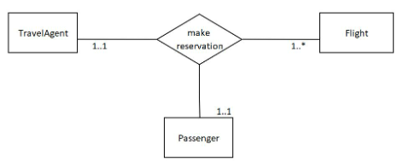
Figure 1: ERD for travel agent.

I. A TravelAgent can make reservation of 1 or more Flight for a Passenger.
II. A TravelAgent can make reservation for 1 or more Passenger.
III. A TravelAgent can make reservation for many Flights.
IV. A Passenger can have 1 or many Flights.

- I only.
- I and II.
- II and III.
- II and IV.

- Which of the following indicates the maximum number of entities that can be involved in a relationship?
- Multiplicity
- Minimum Cardinality
- Maximum Cardinality
- Participation

- As a result of the COVID-19 pandemic, an increasing number of people are purchasing laptops. Jason’s business is now worldwide! Since he will need to ensure that his agents, staff, and customers have uninterrupted access to his applications for purchasing and managing laptops, he has chosen to use Amazon Cloud Service and migrate parts of his databases to the cloud. Thank God for the ANSI-SPARC architecture; these changes will be invisible to his customers and agents! Select the CORRECT data independence type from the options below.
- Logical Data Independence
- Physical Data Independence
- Conceptual Data Independence
- External Data Independence

- Which of the statements is FALSE about the representation of the ERD in Figure 2?

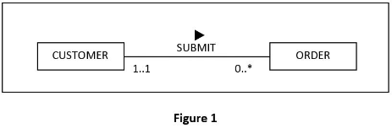

Figure 2: ERD of Customer and Order

- In SUBMIT relationship, CUSTOMER holds a mandatory participation while ORDER holds an optional participation.
- The SUBMIT relationship is a one-to-many relationship.
- A customer can have more than one order or doesn’t have any order at all.
- An order submitted always belongs to one customer only.

- Which attribute(s) make up the candidate key for the following relational schema?

RESERVATION (CustomerID, HotelID, ReservationDate, CheckInDate, CheckOutDate, NumberOfRoom, NumberOfAdults, NumberOfChildren)

- CustomerID
- HotelID
- ReservationDate
- CustomerID, HotelID

- Based on Figure 3, which of the following statements are CORRECT?

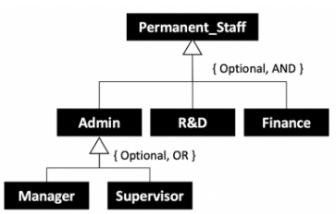
Figure 3: ERD of permanent staff

- Some of the permanent staff are divided into Admin, R&D and Finance.
- A permanent staff can be admin and Finance personnel at the same time.
- There are only two admin positions which are manager and supervisor.
- A staff member can only be either a manager or supervisor but not both.

A. I, II
B. I, III, IV
C. I, II, IV
D. All above

- A publication management system records and manages different types of publications. Majority of the publications are in the forms of journal articles, textbooks, novels. All the journal articles are divided into indexed and non-index publications.
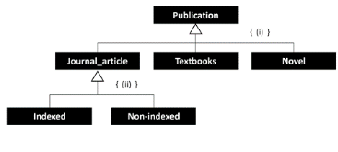
Figure 4: ERD of publication management system

Based on the situation above, fill in the constraints for the structure in Figure 4.
- {mandatory, or} (ii) {mandatory, or}
- {optional, and} (ii) {mandatory, and}
- (i) {optional, or} (ii) {mandatory, or}
- (i) {optional, or} (ii) {mandatory, and}

- Mr. Akmal owns a computer repair shop that provides computer components and system repair services. All his technicians can be divided into regular and on-call, where permanent technicians are those who are hired permanently by the shop and provided a designated monthly salary. Majority of the permanent technicians are focused on laptop components repair and desktop motherboard repair. Some of them are able to do both. Meanwhile on-call technicians are the external technicians who are requested by the shop whenever there are overwhelming repair jobs or special repair cases. These on-call technicians will have their hourly pay rate.
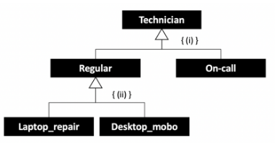
Figure 5: ERD of computer repair shop.

Based on the given situation, fill in the constraints for the structure in Figure 5:
- (i) { Mandatory, OR } (ii) { Mandatory, AND}
- (i) { Mandatory, OR } (ii) { Optional, OR }
- (i) { Mandatory, OR } (ii) { Optional, AND }
- (i) { Optional, OR } (ii) { Optional, AND}

- A student can take not more than 5 subjects in a semester. The number of students allowed in a subject in a semester is not more than 40.

The student – subject relationship is:
- 5:40
- 40:5
- N:5
- 40:M

- The School of Computing, Universiti Teknologi Malaysia offers several courses; each course has several classes. It is possible for the Department to create the entity COURSE first and then create the CLASS entity after making the Teaching assignments. In this case, what cardinality will appear for CLASS in the ERD?
- (0,1)
- (1,1)
- (1,*)
- (0,*)

PART B: STRUCTURED QUESTION (60 MARKS)

QUESTION 1 | [8 MARKS]
You can have data without information, but you cannot have information without data. With data being the core of any successful business, we can’t deny that either. Data helps companies make intelligent decisions about planning their marketing campaigns, managing finances, and developing new products. However, data can become quite overwhelming when it's not organized correctly. To put it simply, businesses are drowning in data.

- How do you keep all this business data in order?
 | (1 Mark)
- What is database? One example of database.
 | (2 Marks)
- What is database management system. One example of DBMS.
 | (2 Marks)
- Give two important point, why do businesses need a database.
 | (3 Marks)

QUESTION 2 | [7 MARKS]
A hotel database shall provide the following information:

Table 1: Information about Guests
IdGuest | FirstName | Last Name | Home Address
1 | Ahmad | Hisham
2 | Muhammad | Anas
3 | Siti | Aminah

Table 2: Information about Rooms
RoomNumber | Type | Rate
201 | Single | 180
202 | Double | 230
203 | Single | 190

Table 3: Information about Stays
IdGuest | RoomNumber | Date
1 | 202 | 1/1/2022
1 | 203 | 5/5/2022
2 | 201 | 1/10/2022

Based on the above Table 1,2,3, answer the following questions:
- Identify TWO (2) relation names.
 | (1 Mark)
- Identify the attributes for Guests and how many degrees?
 | (2 Marks)
- Identify the primary key for Rooms.
 | (1 Mark)
- The possible foreign key for Stays information.
 | (1 Mark)
- Explain about the referential Integrity in between Room and Stays information.
 | (2 Marks)

QUESTION 3 | [8 MARKS]
- List TWO (2) importance of testing phase in Database System Development Lifecycle (DBSDLC).
 | (2 Marks)
- Explain THREE (3) stages that are involved in Database System Development Lifecycle (DBSDLC).
 | (6 Marks)

QUESTION 4 | [7 MARKS]
The following list shows the business rules of sport venue booking system:
- A student {studentId, studentName, phone [1…3]} can make zero or more booking.
- Each booking {bookingId, DateAndTime, studentId, venueId} can be made by one student.
- A sport officer {staffId, staffName} will check for availability of zero or more venue.
- The availability of each venue will be checked by a sport officer.
- A sport officer can approve zero or more booking.
- Each booking can be approved by a sport officer.
- Each booking will reserve for one venue.
- A venue {venueId, venueName, location} can be reserved by one booking at a time.

All IDs are set as variable character (5), integer (15) for phone number, all names and location with variable character (30), and datetime for booking date and time.

Based on the above business rules:
- State all primary keys (PK) for each entity and foreign keys (FK) with its entity, if it exists.
 | (3 Marks)
- Complete a Data Dictionary for sport venue booking system.
(Use table below to show your answer)
Entity Name | Attributes | Data type & length | Multi-valued

 | (4 Marks)

QUESTION 5 | [4 MARKS]
- Explain the difference between a weak and a strong entity set.
 | (2 Marks)
- Describe the two categories of entity type. Any weak entity set can be converted to strong entity set by simply adding appropriate attributes. Why, then, do we have weak entity sets?
 | (2 Marks)

QUESTION 6 | [[11 MARKS]
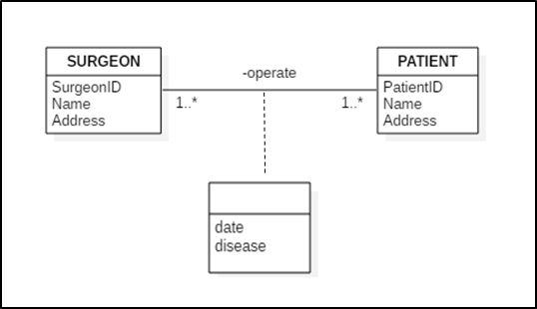

Figure 6: Entity Relationship Diagram
Based on the multiplicity values shown in Figure 6 entity relation diagram (ERD), determine the followings:

- The cardinality constraint for the OPERATE relationship.
 | (1 Mark)
- The participation constraints for the SURGEON entity and PATIENT entity.
 | (2 Marks)
- The entity type for the SURGEON entity and PATIENT entity.  d) The Scenario: | (2 Marks)
Consider the following automotive enterprises, involving cars, car manufacturers, and car dealerships. Car manufacturers (like Honda Motor Company, Perusahaan Otomobil Nasional (PROTON), Mercedes-Benz, BMW, General Motors (GM), etc.) are companies that build cars, and they have attributes such as name, headquarters address, country of incorporation, etc. Cars have attributes such as make (e.g., Honda, Proton, Ford, Volkswagen, Mercedes, etc.), model (e.g. Saga, Iriz, Civic, Accord, etc.), and kind of car (e.g., sedan, SUV, wagon, etc). A dealership sells cars. It has a name, address, and telephone numbers (typically more than one.) Each manufacturer builds at least one car. A manufacturer may make several different kinds and models of cars (as, for example, the manufacturer Mercedes or PROTON does). A car is made by a single manufacturer. A dealership can sell cars from several different manufacturers but does not have to sell all the cars from a single manufacturer. For example, Lestari_Car in Pontian sells Pontiacs from manufacturer GM and Hondas from manufacturer Honda, but it doesn’t sell Chevrolets that are also made by GM. Each dealership sells at least one car, and the date of sale is recorded. A manufacturer can make a car (such as a racing car) that is not sold through dealerships.

Based on the scenario given, draw a conceptual entity relationship diagram (ERD) using UML notation to represent the data model.
 | (6 Marks)

QUESTION 7 | [15 MARKS]
- Distinguish between disjoint and non-disjoint constraints in the Enhanced ERD.
 | (2 Marks)
- Determine the participation and disjoint constraints for each description given in Figures 7, 8 and 9.
[Note: Indicate with {a,b}, {c,d} and {e,f}]
- UTM Libraries manage a wide range of references, including books, theses, and journals.  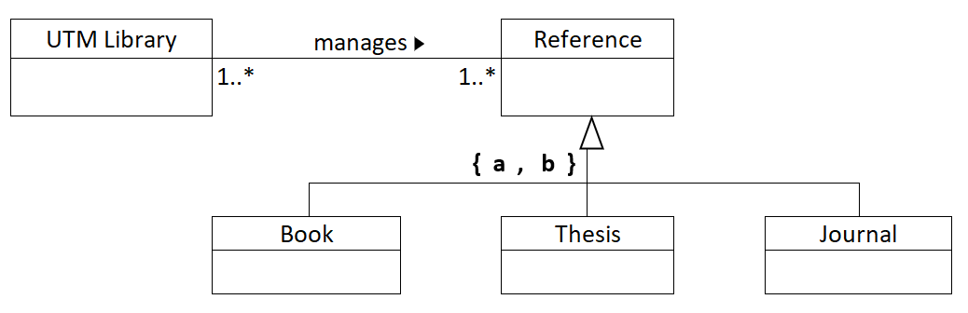  Figure 7: EERD | (2 Marks)
- Faculty of Computing employees are classified as administrators, support staff, and academic staff. Some academic staff are administrators. Allowance is recorded for the administrator, while overtime is recorded for support staff.  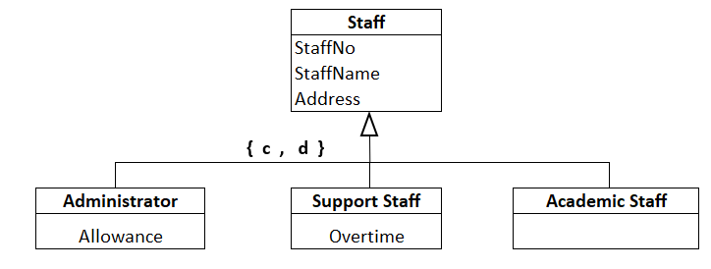  Figure 8: EERD | (2 Marks)
- The SOMECAR company rents two types of vehicles: cars and trucks. The number of passengers and the maximum speed of a car type vehicle are recorded. In the case of a truck, the axle number and tonnage of the truck are recorded.  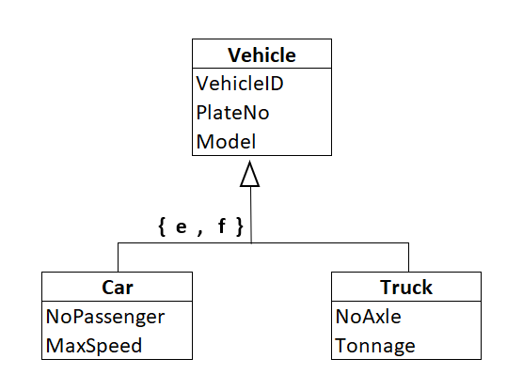  Figure 9: EERD | (2 Marks)
- Consider the following requirements for the Syarikat ALIBABA Sdn. Bhd. database, which is used to keep track of staff information.
- Syarikat ALIBABA Sdn. Bhd. keeps track of each staff's number, name (first and last name), current address, and phone number.
- Some applications require the city, state, and ZIP code of the staff's current address.
- The data stored on the vehicle includes the vehicleNo, model, and price.
- Each staff owns one or more vehicles that are categorized as car or motorcycle.

Based on the requirements, draw a conceptual Entity-Relationship Diagram (ERD) or Enhanced ERD.
 | (7 Mark)

PART C: CASE STUDY QUESTION (20 MARKS)

Your company was assigned to develop a data model for a database application system for a small retail store called World Soccer League (WSL). The WSL store sells merchandise items from local soccer teams. Each item would be associated with a local soccer team. Customers are free to purchase any item and the item would be recorded for future reference. Figure 10 below shows the ERD for the WSL store (note that all attributes should not be null).

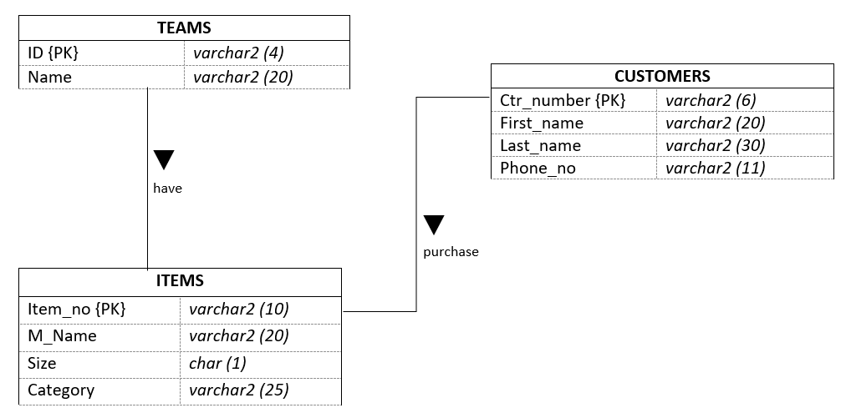
Figure 10: ERD of World Soccer League retail store

Construct SQL statements for each of the following problems.

- Based on the ERD in Figure 10, create all tables for WSL store.
(5 marks)

- Add new attribute in table:

  - ITEMS named color with datatype Varchar2 with size 15.
  - CUSTOMERS named address with datatype Varchar2 with size 50.
(2 marks)

- Rename attribute name to team_name in table TEAM.
(1 mark)

- For table ITEMS:

  - Remove attribute category from table ITEMS.
  - Change the size attribute datatype to number with size 2.
(2 marks)

- Refer to table TEAM and ITEMS below, insert the last two rows into the assigned table:

- Table name: TEAM
id | team_name
JYT | Yes Team
JTB | Tiger Best
JSG | South Group
JBP | Black Pack
JAE | Awesome Eagle

- Table name: ITEMS
item_no | m_name | size | team_id
JYT001 | YT Jersey | 32 | JYT
JYT002 | YT Sweater | 34 | JYT
JSG011 | SG Jersey | 40 | JSG
JBP001 | BP Jersey | 40 | JBP
JSG021 | SG Boot | 36 | JSG
JAE001 | AE Shorts | 32 | JAE
(4 marks)

- Assumed the data in table CUSTOMERS was inserted to the database.

Table name: CUSTOMERS
ctr_number | first_name | last_name | phone_number | item_no
1567 | Edwin | Wong | 0187562599 | JSG021
7892 | Mohamad | Faiz | 0178890040 | JAE001
…
…
8782 | Mohamad | Omar | 0169064690 | JSG021
9088 | Alifah | Amran | 0113679081 | JBP001

- The cashier was informed that a customer, Mohamad (ID = 8782), changed his phone number. Update his phone number to 011-4556341.
- Customer named Alifah noticed that her last name was wrongly keyed in to the system, update her last name to Armane
(5 marks)

- The stock manager noticed that all jerseys with size 40 were sold out. Delete all items
with size = 40.
(1 mark)

